Project Report

On

Cycle Web Site

# Submitted to CBSE, New Delhi



**Submitted To: Submitted By:**

**Mr. Hardeep Singh Gurjot Singh**

**(Head of Department, Comp. Sc.) Rno: 04**

**10+2 Arts**

**Guru Gobind Singh Public School**

**Village Daad, (LUDHIANA)**

***Main Page***

<html>

<head>

<title>Home</title>

<link rel="icon" type="image/png" href="images/favii.gif" />

<link href="index.css" rel="stylesheet" style type="text/css" />

</head>

<body>

<div id="container">

<div id="social">

<br />

<img src="images/fb_blue.png" />

&nbsp;&nbsp;&nbsp;

<img src="images/tweet_a.png" />

</div>

<div id="logo"><img src="images/logo1.png" /></div>

<div id="menu1">

<ul>

<li><a href="index.html">HOME</a></li>

<li><a href="aboutus.html">ABOUT US</a></li>

<li><a href="kids.html">KIDS CYCLE</a></li>

<li><a href="mens.html">MENS CYCLE</a></li>

<li><a href="contactus.html">CONTACT</a></li>

<li><a href="feedback.html">FEEDBACK</a></li>

</ul>

</div>

<div id="images">

<img src="product/cycle-banner.jpg" height="280px" width="1000px"/>

</div>

<div id="contant120">

<div id="left1">

<div id="image">

<div id="imag">

<marquee behavior="alternate" direction="up" scrollamount="10" height="470px" style="margin-top:5px;">

<img src="product/k3.jpg" height="180px" width="220px"/>

<img src="product/k1.jpg" height="180px" width="220px"/>

<img src="product/k4.jpg" height="180px" width="220px"/>

<img src="product/k2.jpg" height="180px" width="220px"/>

</marquee>

</div>

</div>

</div>

<div id="right1">

<div id="image2">

<div id="imag2">

<marquee behavior="alternate" direction="down" scrollamount="10" height="470px" style="margin-top:5px;">

<img src="product/m1.jpg" height="180px" width="220px"/>

<img src="product/m2.jpg" height="180px" width="220px"/>

<img src="product/m3.jpg" height="180px" width="220px"/>

<img src="product/m4.jpg" height="180px" width="220px"/>

</marquee>

</div>

</div>

</div>

<div id="centerdata" class="justify">

<font color="#323941" size="+3"><center>Welcome To City Cycles</center></font>

<font color="#323941">City Cycles is a product of this philosophy. The philosophy that instills commitment, team work and foresight. City’s colossal journey started before independence. The four Munjal brothers, hailing from a small town called Kamalia, now in Pakistan, are the men who are behind the mission. Brotherhood apart, what knit the men together was the wealth of will, integrity, ambition & determination. In the year 1944, they decided to start a business of bicycle spare parts in Amritsar.But the dark clouds of partition eclipsed their plans of the future. With renewed vigour and optimism, the operational base was shifted to Ludhiana. By 1956, the brothers had began manufacturing key components of bicycles and as a logical way forward, began to assemble the entire cycle at their manufacturing plant in Ludhiana. In the early days, the plant had a capacity for 25 cycles per day. Over the next few years, the Bicycle Unit started growing in stature and size, attracting skilled engineers, technocrats, administrators and entrepreneurs. From a modest beginning of mere 639 bicycles in the year 1956, City Cycles products over 18500 cycles a day today, the highest in global reckoning. </font>

</div>

</div>

<div id="footer" style="margin-top:5px;">

<ul>

<li><a href="index.html">HOME</a></li>

<li><a href="aboutus.html">ABOUT US</a></li>

<li><a href="kids.html">KIDS CYCLE</a></li>

<li><a href="mens.html">MENS CYCLE</a></li>

<li><a href="contactus.html">CONTACT</a></li>

<li><a href="feedback.html">FEEDBACK</a></li>

</ul>

<br />

<br />

<div style="float:right">Copyright &copy; Gurjot Singh&nbsp;&nbsp;&nbsp;</div></div>

</div>

</body>

</html>

**OUTPUT**

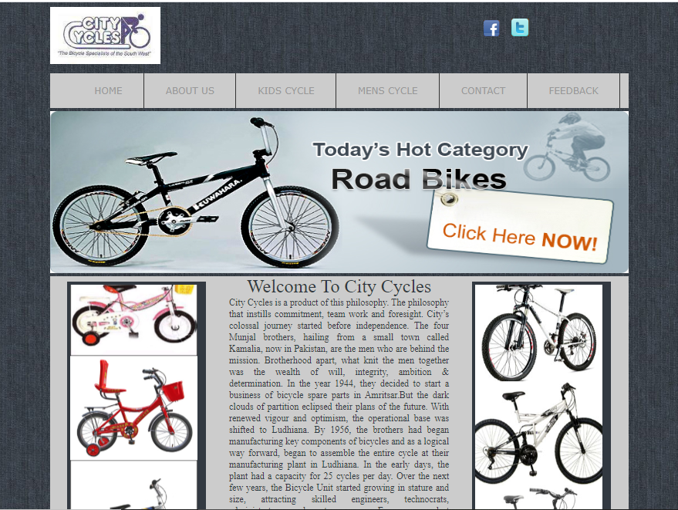

**About Us Page**

<html>

<head>

<title>About Us</title>

<link rel="icon" type="image/png" href="images/favii.gif" />

<link href="index.css" rel="stylesheet" style type="text/css" />

</head>

<body>

<div id="container">

<div id="social">

<br />

<img src="images/fb_blue.png" />

&nbsp;&nbsp;&nbsp;

<img src="images/tweet_a.png" />

</div>

<div id="logo"><img src="images/logo1.png" /></div>

<div id="menu1">

<ul>

<li><a href="index.html">HOME</a></li>

<li><a href="aboutus.html">ABOUT US</a></li>

<li><a href="kids.html">KIDS CYCLE</a></li>

<li><a href="mens.html">MENS CYCLE</a></li>

<li><a href="contactus.html">CONTACT</a></li>

<li><a href="feedback.html">FEEDBACK</a></li>

</ul>

</div>

<div id="images">

<marquee behavior="alternate" scrollamount="10" >

<img src="product/k1.jpg" height="200px" width="300px"/>

<img src="product/m1.jpg" height="200px" width="300px"/>

<img src="product/k2.jpg" height="200px" width="300px"/>

<img src="product/m2.jpg" height="200px" width="300px"/>

</marquee>

</div>

<div id="contant120">

<br />

<p><center>About Us</center></p></font>

<center><img src="images/about.jpg" height="200px" width="400px" /><center>

<font size="+3">City Cycles</font><br /><br />

<font size="4" face="Arial, Helvetica, sans-serif" color="#333333">A renowned name in the manufacturing of Cycles in North India,

<p style="line-height:30px;"> City Cycles is a product of this philosophy. The philosophy that instills commitment, team work and foresight. City’s colossal journey started before independence. The four Munjal brothers, hailing from a small town called Kamalia, now in Pakistan, are the men who are behind the mission. Brotherhood apart, what knit the men together was the wealth of will, integrity, ambition & determination. In the year 1944, they decided to start a business of bicycle spare parts in Amritsar.But the dark clouds of partition eclipsed their plans of the future. With renewed vigour and optimism, the operational base was shifted to Ludhiana. By 1956, the brothers had began manufacturing key components of bicycles and as a logical way forward, began to assemble the entire cycle at their manufacturing plant in Ludhiana. In the early days, the plant had a capacity for 25 cycles per day. Over the next few years, the Bicycle Unit started growing in stature and size, attracting skilled engineers, technocrats, administrators and entrepreneurs. From a modest beginning of mere 639 bicycles in the year 1956, City Cycles products over 18500 cycles a day today, the highest in global reckoning.<br />A tiny acorn has now become a mighty Oak. From cycle to two - wheelers was a natural step, and the Hero Group came into being. The Hero Group, today, is a vast conglomerate of companies, either in the form of collaborations, joint ventures or fully owned subsidiaries, with more than Rs. 10000 Crore turnover annually. Hero Group, besides being the world’s largest manufacturers of bicycles, motorcycles and chains to this date, has diversified into newer segments like Information Technology, IT Enabled Services and Financial Services</p></font>

</div>

<div id="footer" style="margin-top:5px;">

<ul>

<li><a href="index.html">HOME</a></li>

<li><a href="aboutus.html">ABOUT US</a></li>

<li><a href="kids.html">KIDS CYCLE</a></li>

<li><a href="mens.html">MENS CYCLE</a></li>

<li><a href="contactus.html">CONTACT</a></li>

<li><a href="feedback.html">FEEDBACK</a></li>

</ul>

<br />

<br />

<div style="float:right">Copyright &copy; Gurjot Singh&nbsp;&nbsp;&nbsp;</div></div>

</div>

</body>

</html>

**OUTPUT**

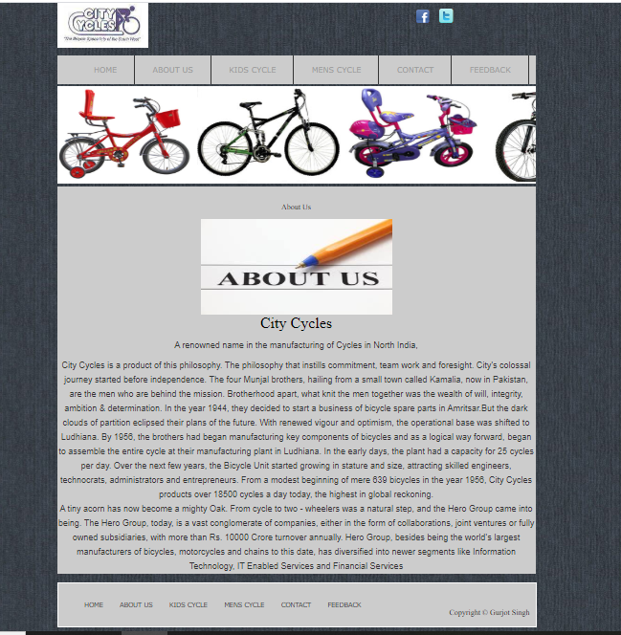

**Kids Cycle Page**

<html>

<head>

<title>Kids Cycle</title>

<link rel="icon" type="image/png" href="images/favii.gif" />

<link href="index.css" rel="stylesheet" style type="text/css" />

</head>

<body>

<div id="container">

<div id="social">

<br />

<img src="images/fb_blue.png" />

&nbsp;&nbsp;&nbsp;

<img src="images/tweet_a.png" />

</div>

<div id="logo"><img src="images/logo1.png" /></div>

<div id="menu1">

<ul> <li><a href="index.html">HOME</a></li>

<li><a href="aboutus.html">ABOUT US</a></li>

<li><a href="kids.html">KIDS CYCLE</a></li>

<li><a href="mens.html">MENS CYCLE</a></li>

<li><a href="contactus.html">CONTACT</a></li>

<li><a href="feedback.html">FEEDBACK</a></li>

</ul>

</div>

<div id="images">

<marquee behavior="alternate" scrollamount="10" >

<img src="product/k1.jpg" height="200px" width="300px"/>

<img src="product/m1.jpg" height="200px" width="300px"/>

<img src="product/k2.jpg" height="200px" width="300px"/>

<img src="product/m2.jpg" height="200px" width="300px"/>

</marquee>

</div>

<div id="contant120">

<br />

<table align="center" cellspacing="50" >

<tr>

<th class="bg"><img src="product/k1.jpg" height="250" width="250"/><br />1</th>

<th class="bg"><img src="product/k2.jpg" height="250" width="250"/><br />2</th>

<th class="bg"><img src="product/k3.jpg" height="250" width="250"><br />3</th>

</tr>

<tr>

<th class="bg"><img src="product/k4.jpg" height="250" width="250"/><br />4</th>

<th class="bg"><img src="product/k5.jpg" height="250" width="250"/><br />5</th>

<th class="bg"><img src="product/k6.jpg" height="250" width="250"><br />6</th>

</tr>

<tr>

<th class="bg"><img src="product/k7.jpg" height="250" width="250"/><br />7</th>

<th class="bg"><img src="product/k8.jpg" height="250" width="250"/><br />8</th>

</tr>

</table>

</div>

<div id="footer" style="margin-top:5px;">

<ul>

<li><a href="index.html">HOME</a></li>

<li><a href="aboutus.html">ABOUT US</a></li>

<li><a href="kids.html">KIDS CYCLE</a></li>

<li><a href="mens.html">MENS CYCLE</a></li>

<li><a href="contactus.html">CONTACT</a></li>

<li><a href="feedback.html">FEEDBACK</a></li>

</ul>

<br />

<br />

<div style="float:right">Copyright &copy; Gurjot Singh&nbsp;&nbsp;&nbsp;</div></div>

</div>

</body>

</html>

**OUTPUT**

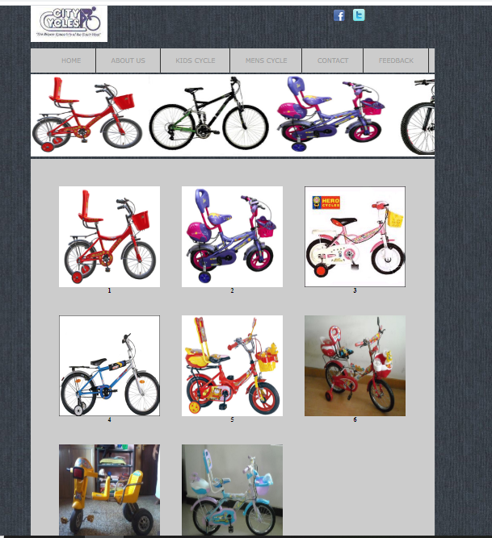

**Mens Cycle Page**

<html>

<head>

<title>Cars Website</title>

</head>

<body background="IMAGES/bg.jpg">

<font face="Trebuchet MS">

<h2 align="center"><img src="IMAGES/logo.jpg"></h2>

<table align="center" width="900px" border="1">

<tr bgcolor="#FE3919" height="35">

<th align="center"><a href="main.htm">Home</a></th>

<th align="center"><a href="aboutus.htm">About Us</a></th>

<th align="center"><a href="newcars.htm">New Cars</a></th>

<th align="center"><a href="usedcars.htm">Used Cars</a></th>

<th align="center"><a href="contactus.htm">Contact Us</a></th>

<th align="center"><a href="feedback.html">Feedback</a></th>

</tr>

<tr>

<td colspan="6">

<img src="images\banner.jpg" width="1000px" height="200px">

</td>

</tr>

<tr>

<td colspan="6">

<table cellpadding="5" width="700" align="center">

<tr>

<td colspan="6" bgcolor="#333">

<font color="#FFFFFF">

<h3 align="center">Our Cars</h3>

</font>

<table align="center" cellspacing="5" width="900px" >

<tr>

<th><img src="images\inn.jpg"><font color="white"><br>Buying Price: 2000$ &nbsp;&nbsp;&nbsp;&nbsp;&nbsp;&nbsp;&nbsp;&nbsp;&nbsp;<a href="inn.html"><font color="#FFFFFF">READ MORE</font></a></th>

<th><img src="images\cruze.jpg"><font color="white"><br>Buying Price: 4500$ &nbsp;&nbsp;&nbsp;&nbsp;&nbsp;&nbsp;&nbsp;&nbsp;&nbsp;<a href="cruze.html"><font color="#FFFFFF">READ MORE</font></a></th>

<th><img src="images\sunny.jpg"><font color="white"><br>Buying Price: 2500$ &nbsp;&nbsp;&nbsp;&nbsp;&nbsp;&nbsp;&nbsp;&nbsp;&nbsp;<a href="sunny.html"><font color="#FFFFFF">READ MORE</font></a></th>

</tr>

<tr>

<th><img src="images\laura.jpg"><font color="white"><br>Buying Price: 10000$ &nbsp;&nbsp;&nbsp;&nbsp;&nbsp;&nbsp;&nbsp;&nbsp;&nbsp;<a href="laura.html"><font color="#FFFFFF">READ MORE</font></a></th>

<th><img src="images\scor.jpg"><font color="white"><br>Buying Price: 3200$ &nbsp;&nbsp;&nbsp;&nbsp;&nbsp;&nbsp;&nbsp;&nbsp;&nbsp;<a href="scor.html"><font color="#FFFFFF">READ MORE</font></a></th>

<th><img src="images\ver.jpg"><font color="white"><br>Buying Price: 2700$ &nbsp;&nbsp;&nbsp;&nbsp;&nbsp;&nbsp;&nbsp;&nbsp;&nbsp;<a href="ver.html"><font color="#FFFFFF">READ MORE</font></a></th>

</tr>

</table>

</td>

</tr>

</table>

</td>

</tr>

</table>

</font>

</body>

</html>

**OUTPUT**

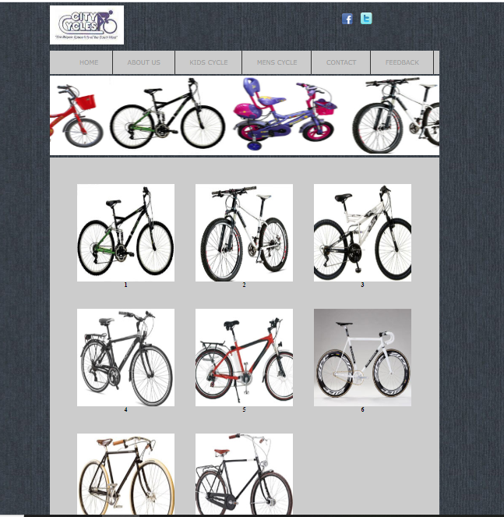

**Contact Us Page**

<html>

<head>

<title>Contact Us</title>

<link rel="icon" type="image/png" href="images/favii.gif" />

<link href="index.css" rel="stylesheet" style type="text/css" />

</head>

<body>

<div id="container">

<div id="social">

<br />

<img src="images/fb_blue.png" />

&nbsp;&nbsp;&nbsp;

<img src="images/tweet_a.png" />

</div>

<div id="logo"><img src="images/logo1.png" /></div>

<div id="menu1">

<ul>

<li><a href="index.html">HOME</a></li>

<li><a href="aboutus.html">ABOUT US</a></li>

<li><a href="kids.html">KIDS CYCLE</a></li>

<li><a href="mens.html">MENS CYCLE</a></li>

<li><a href="contactus.html">CONTACT</a></li>

<li><a href="feedback.html">FEEDBACK</a></li>

</ul>

</div>

<div id="images">

<marquee behavior="alternate" scrollamount="10" >

<img src="product/k1.jpg" height="200px" width="300px"/>

<img src="product/m1.jpg" height="200px" width="300px"/>

<img src="product/k2.jpg" height="200px" width="300px"/>

<img src="product/m2.jpg" height="200px" width="300px"/>

</marquee>

</div>

<div id="contant120">

<br />

<center><font size="+2">Welcome to the official website of City Cycles Ludhiana, Punjab, India</center>

<center>Contact Us</center></font>

<center><img src="images/contactus.211170115_std.jpg" height="200px" width="400px" /><center>

<font size="+2"><center>City Cycles</center></font>

<h2>

<p> Name Gurjot Singh</p>

<p> Roll NO 04 </p>

<p> Class 10+2 Arts </p>

<p> Guru Gobind Singh Public School </p>

<p>VPO DAAD LUDHIANA , PUNJAB</p>

<p>Mobile NO. 97818-21764</p>

<p>Email us :- citycyles@yahoo.com</p>

</h2>

*****************************

</div>

<div id="footer" style="margin-top:5px;">

<ul> <li><a href="index.html">HOME</a></li>

<li><a href="aboutus.html">ABOUT US</a></li>

<li><a href="kids.html">KIDS CYCLE</a></li>

<li><a href="mens.html">MENS CYCLE</a></li>

<li><a href="contactus.html">CONTACT</a></li>

<li><a href="feedback.html">FEEDBACK</a></li>

</ul>

<br />

<br />

<div style="float:right">Copyright &copy; Gurjot Singh &nbsp;&nbsp;&nbsp;</div></div>

</div>

</body>

</html>

**OUTPUT**

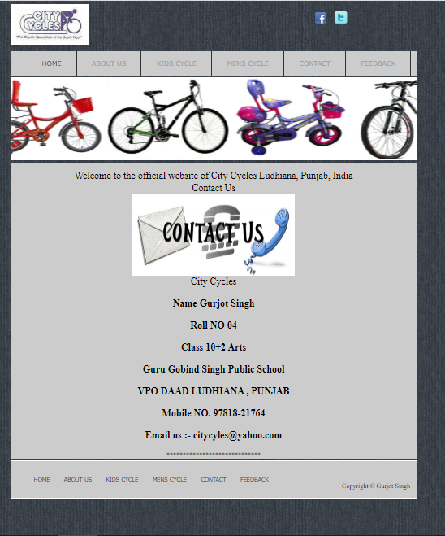

**FEEDBACK FORM**

<html>

<head>

<title>Feedback Form</title>

<link rel="icon" type="image/png" href="images/favii.gif" />

<link href="index.css" rel="stylesheet" style type="text/css" />

</head>

<body>

<div id="container">

<div id="social">

<br />

<img src="images/fb_blue.png" />

&nbsp;&nbsp;&nbsp;

<img src="images/tweet_a.png" />

</div>

<div id="logo"><img src="images/logo1.png" /></div>

<div id="menu1">

<ul>

<li><a href="index.html">HOME</a></li>

<li><a href="aboutus.html">ABOUT US</a></li>

<li><a href="kids.html">KIDS CYCLE</a></li>

<li><a href="mens.html">MENS CYCLE</a></li>

<li><a href="contactus.html">CONTACT</a></li>

<li><a href="feedback.html">FEEDBACK</a></li>

</ul>

</div>

<div id="images">

<marquee behavior="alternate" scrollamount="10" >

<img src="product/k1.jpg" height="200px" width="300px"/>

<img src="product/m1.jpg" height="200px" width="300px"/>

<img src="product/k2.jpg" height="200px" width="300px"/>

<img src="product/m2.jpg" height="200px" width="300px"/>

</marquee>

</div>

<div id="contant120">

<br />

<table border="1" style="color:#C00" align="center" width="75%" >

<tr>

<td colspan="2">

<h2 align="center"> Javascript Coding</h2>

<script type="text/javascript">

x=prompt("Enter Your Name")

document.write("Hello ")

document.write(x)

</script>

</td>

</tr>

<tr>

<td colspan="5"><center><font size="+3"><b>Feedback Form</b></font></center></td>

</tr>

<tr>&nbsp;<br /></tr>

<tr>

<td align="center">Your name:</td>

<td align="center"><font face="Arial"><input name="name"></font></td>

</tr>

<tr>

<td align="center"><font color="#000080" size="1">*</font> Your email address:</td>

<td align="center"><font face="Arial"><input name="email"></font></td>

</tr>

<tr align="middle">

<td align="center"><font color="#000080" size="1">*</font> Confirm email address:</td>

<td align="center"><font face="Arial"><input name="email2"></font></td>

</tr>

<tr>

<td align="center"><font color="#000080" size="1">*</font>Contact No:</td>

<td align="center"><font face="Arial"><input name="contact"></font></td>

</tr>

<tr>

<td align="center"><font color="#000080" size="1">*</font>Fax</td>

<td align="center"><font face="Arial"><input name="fax"></font></td>

</tr>

<tr>

<td align="center"><font color="#000080" size="1">*</font> Subject:</td>

<td align="center"><font face="Arial"><input name="thesubject"></font></td>

</tr>

<tr>

<td align="center">&nbsp;<font color="#000080" size="1">*</font> Your request or query:</td>

<td align="center"><textarea style="FONT-SIZE: 10pt" name="themessage" rows="7" cols="40"></textarea></td>

</tr>

<tr>

<td colspan="2" align="center"><input type="button" value="Send" name="B1" >You must fill in the fields marked with *</td>

</tr>

</table>

</div>

<div id="footer" style="margin-top:5px;">

<ul>

<li><a href="index.html">HOME</a></li>

<li><a href="aboutus.html">ABOUT US</a></li>

<li><a href="kids.html">KIDS CYCLE</a></li>

<li><a href="mens.html">MENS CYCLE</a></li>

<li><a href="contactus.html">CONTACT</a></li>

<li><a href="feedback.html">FEEDBACK</a></li>

</ul>

<br />

<br />

<div style="float:right">Copyright &copy; Gurjot Singh&nbsp;&nbsp;&nbsp;</div></div>

</div>

</body>

</html>

**OUTPUT**

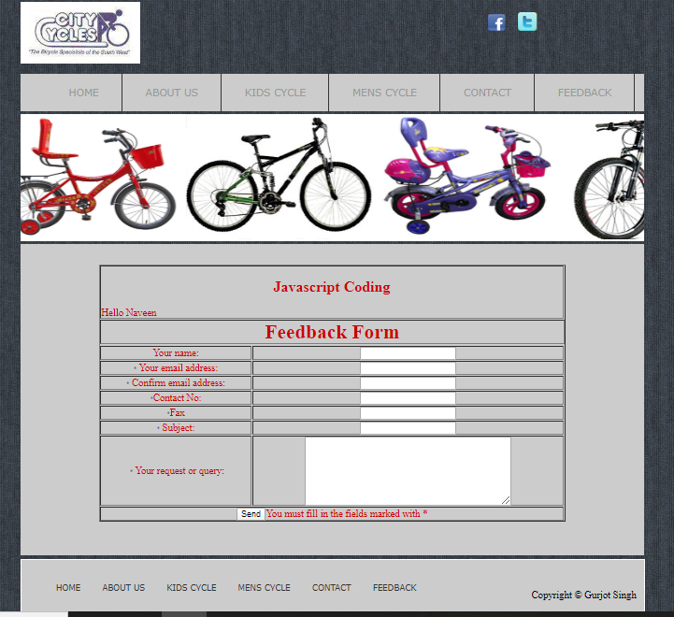

**Style.css Page**

body

{

background-image:url(images/dark.jpg);

background-repeat:repeat;

}

#container

{

width:1000px;

min-height:750px;

margin:0 auto;

}

#menu1

{

width:1000px;

height:60px;

background-color:#ccc;

}

#menu1 li

{

font-family:Verdana, Geneva, sans-serif;

font-size:16px;

padding:20px 37px 0px 37px;

display:block;

height:40px;

float:left;

border-right:1px solid #333;

}

#social

{

float:right;

height:80px;

width:250px;

}

#menu1 li a:hover

{

color:#323941;

}

#menu1 a

{

text-decoration:none;

font-family:Verdana, Geneva, sans-serif;

font-size:16px;

display:block;

height:40px;

color:#999;

}

/* search */

#images

{

width:1000px;

background-color:#FFF;

margin-top:5px;

}

#contant120

{

width:1000px;

min-height:500px;

background-color:#CCC;

margin-top:5px;

}

#left1

{

width:250px;

background-color:#ccc;

min-height:480px;

float:left;

}

#image

{

width:240px;

height:480px;

background-color:#323941;

margin-top:10px;

margin-left:30px;

}

#image2

{

width:240px;

height:480px;

background-color:#323941;

margin-top:10px;

}

#imag

{

width:230px;

height:480px;

margin-left:5px;

text-align:center;

}

#imag2

{

width:230px;

height:480px;

margin-left:5px;

behavior: url(/css/border-radius.htc);

border-radius: 25px;

text-align:center;

}

#right1

{

width:270px;

min-height:480px;

float:right;

}

#centerdata

{

width:380px;

height:480px;

margin-left:310px;

}

.clear1

{

clear:both;

}

.justify

{

text-align:justify;

}

#footer

{

width:998px;

height:90px;

margin-top:-10px;

border: #fff thin solid;

background-color:#ccc;

}

#footer li

{

font-family:Verdana, Geneva, sans-serif;

font-size:13px;

padding:20px 20px 0px 15px;

display:block;

height:40px;

float:left;

}

#footer li a{text-decoration:none; color:#333}

.bg {

border: 1px solid #CCC;

height:180px; width:200px;

}